Vanier College

Computer Science Technology Program

Pyrotechnics Store

Website

**User Guide**

Meerab Khan (2388387), Jacob Magera

420‐311‐VA: Internet Programming (Sec‐01)

Teacher: Sleiman Rabah

Thursday, May 26, 2025

Table of Contents

Introduction: 3

Interactive Features: 3

Target audience: 3

Home Page: 4

Contact Us Page: 5

Login Form: 6

Shopping Cart Page: 9

Checkout Form 10

Product Listing Page 11

Product Details Page 13

Search Feature 14

Remote Data Rendering Page 15

Page responsive: 17

GitHub: 17

# Introduction:

We envision a website that provides all your pyrotechnic needs! We will offer products such as fireworks, pyrotechnic equipment, smoke grenades, firecrackers, and automotive airbags etc. The website will let users browse, explore, and add products to their shopping cart.

# Interactive Features:

* -Easily navigate pages with a simple navigation menu with broad categories (Home, Shop, Events, About us, Contact).
* -An interactive shopping cart with updates such as adding and removing products and tickets.
* -Search bar to sort or filter items in different categories.
* -Secure account creation for users to login.
* - Remote data rendering for products available and user reviews. -A design that is adaptive on mobiles, desktops and different devices.
* -The store targets a market specialized uniquely in pyrotechnic products, making it unique by serving specific requirements.
* -Users can browse products with descriptions and special offers for buying fireworks and getting tickets for an event.

# Target audience:

Our target audience are event organizers, fireworks enthusiasts that are interested in shopping for different events like celebrations, festivals, and shows, automotive specialists and technicians, as well as for at-home pyromaniacs. The goal is to make an easy way for customers to explore and compare products by providing information they need, keeping them up to date for different events happening and giving them inspiration for the use of our products, without actual client and server exchange on purchasing or payment processing.

# Home Page:

The home webpage includes an overview of the store and its mission. It displays different images of products in a dynamic carousel. It serves as a menu for navigation to different sections and links.

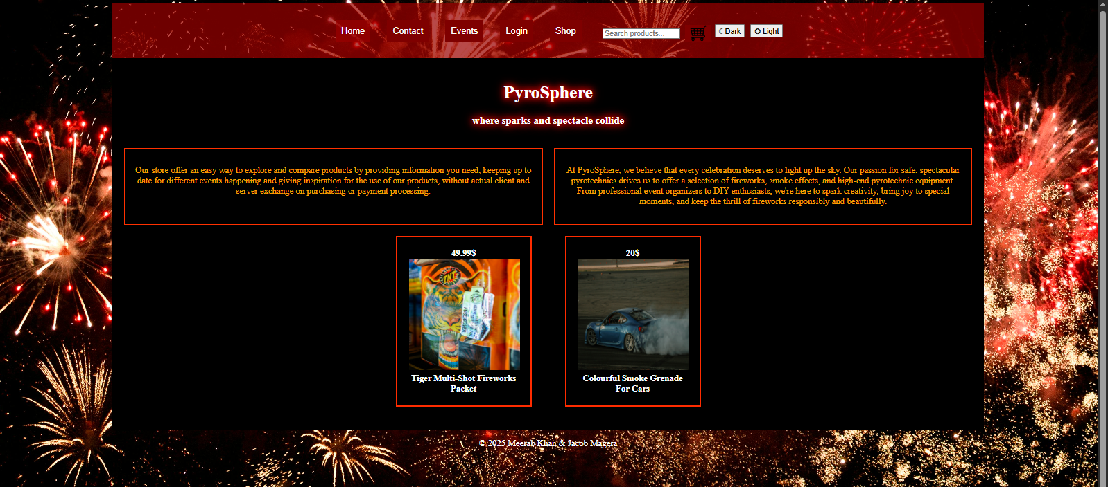

# Contact Us Page:

# To contact and submit inquiry forms or user questions, the contact us page serves best. It stores contact details (email, name).

# 

# Login Form:

To login and access checkout form after clicking the button proceed to checkout in cart page or you can login before putting items to cart.

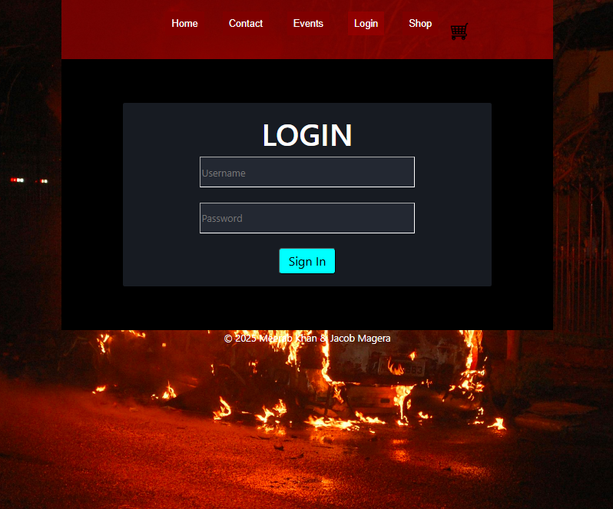

If a user tries to sign up by not entering the fields required: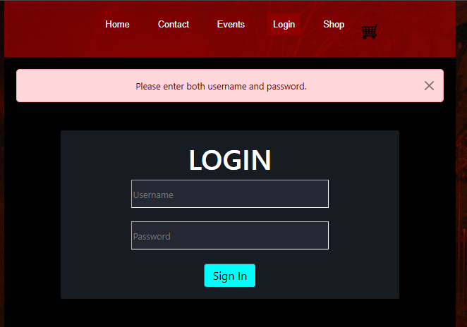

If the password format doesn't match: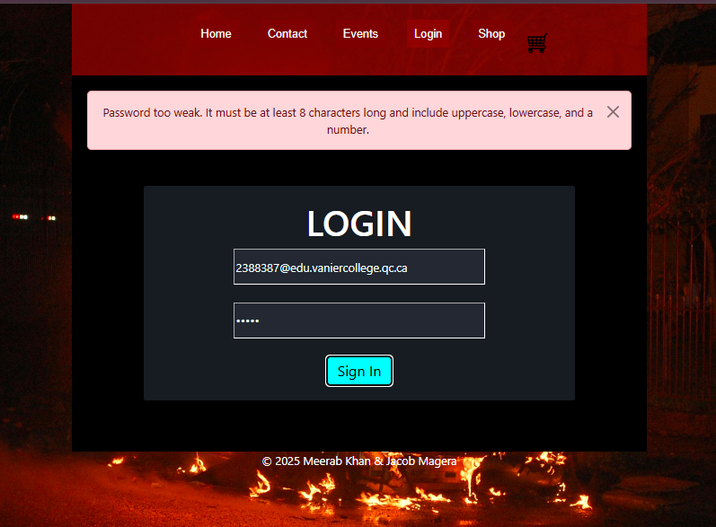

If the email is not well formatted:

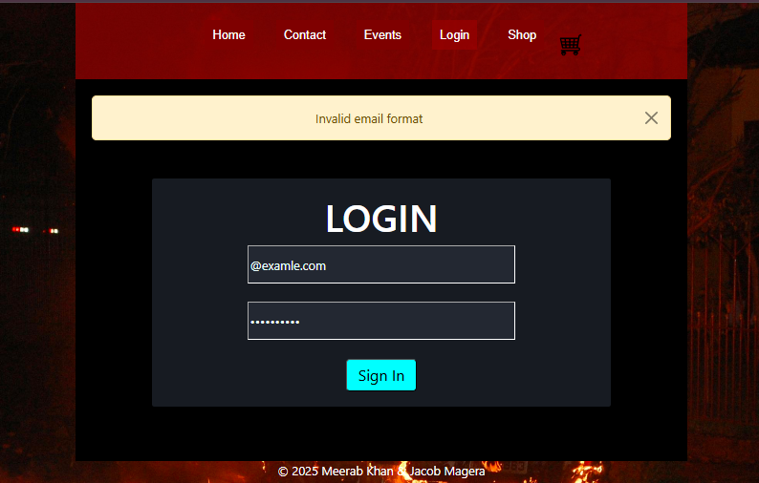

# Shopping Cart Page:

Users can view their items added to the cart. They are updates on quantities and options to remove, add items in cart, and calculate total price. Since there isn't a client server side there is no actual payment. When the user logs in, he can view the cart again and proceed to check out

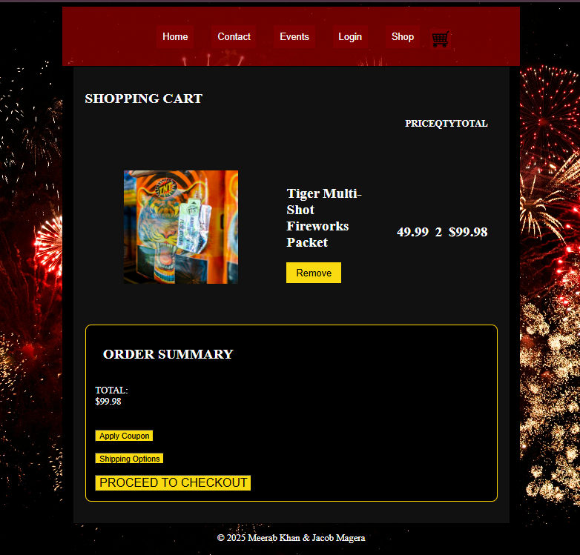

# Checkout Form

The checkout form validates user inputs before placing an order. The user fills in contact information, shipping details, and card information.

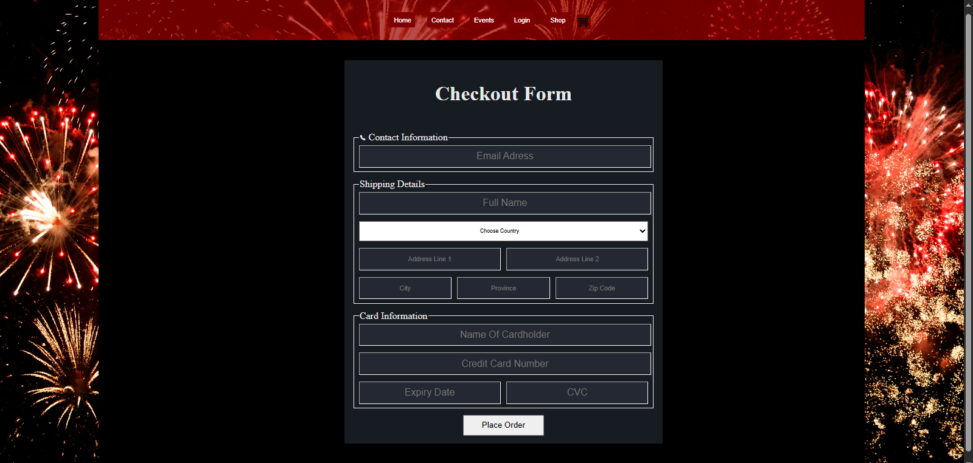

# Product Listing Page

The product listing page is a catalog of products with images, prices, and short descriptions like titles. Filter and sorting options are present and based on different categories, price ranges, and availability.

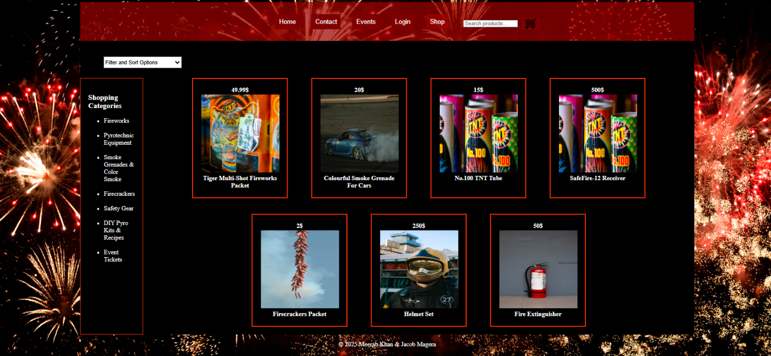

When prices are low to high

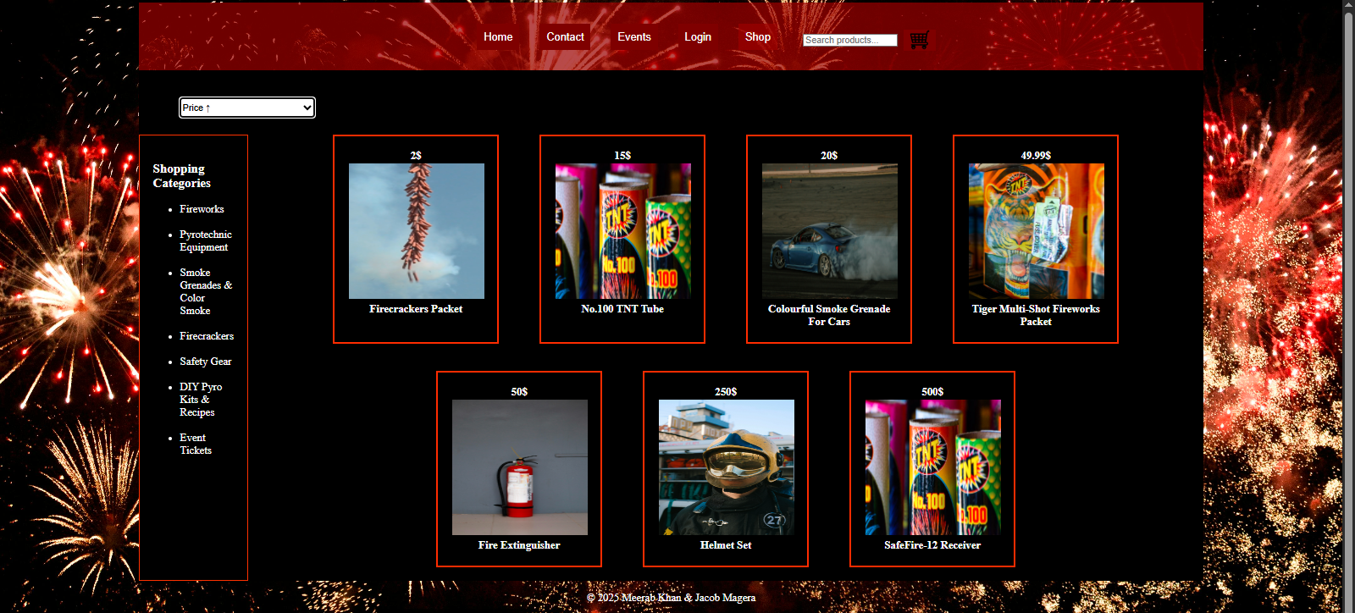

When price is high to low:

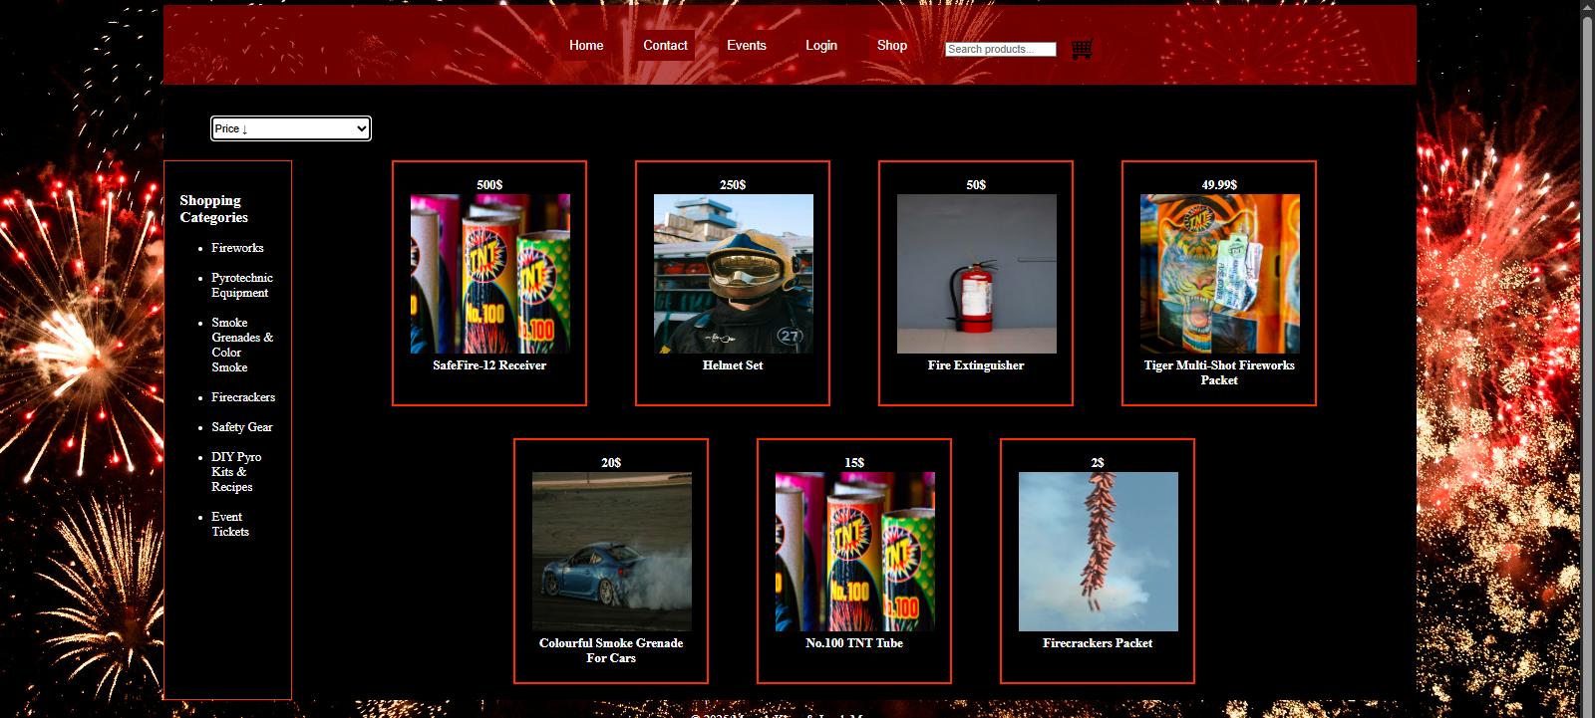

When category is clicked like fireworks the shop page shows:

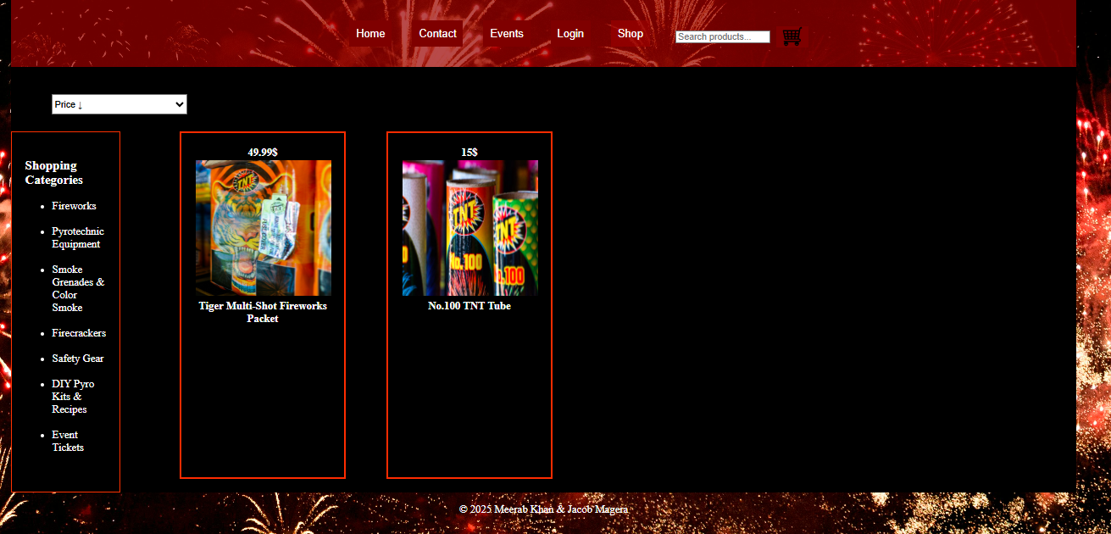

# Product Details Page

The product details page is linked with the product listing page, in which there are images, specifications, and pricing, and “Add to Cart” button with in-depth descriptions.

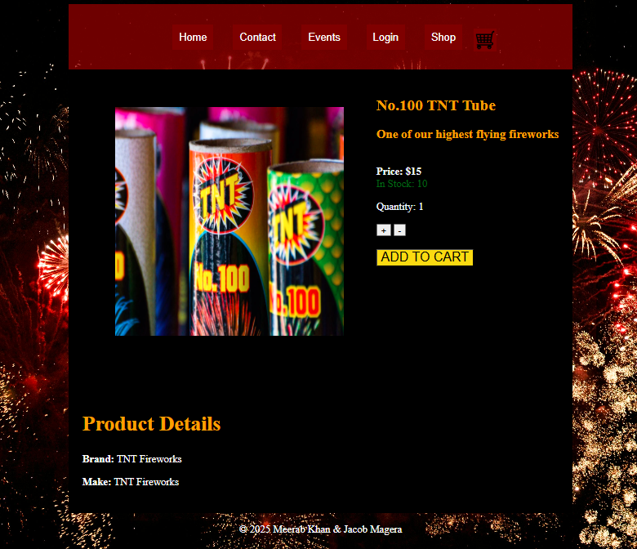

# Search Feature

Search feature pages use a search bar letting users to look up products by name. There can be a loop through the products to get the closest match of the user's input. For example, if a user searches Fire near the cart button:

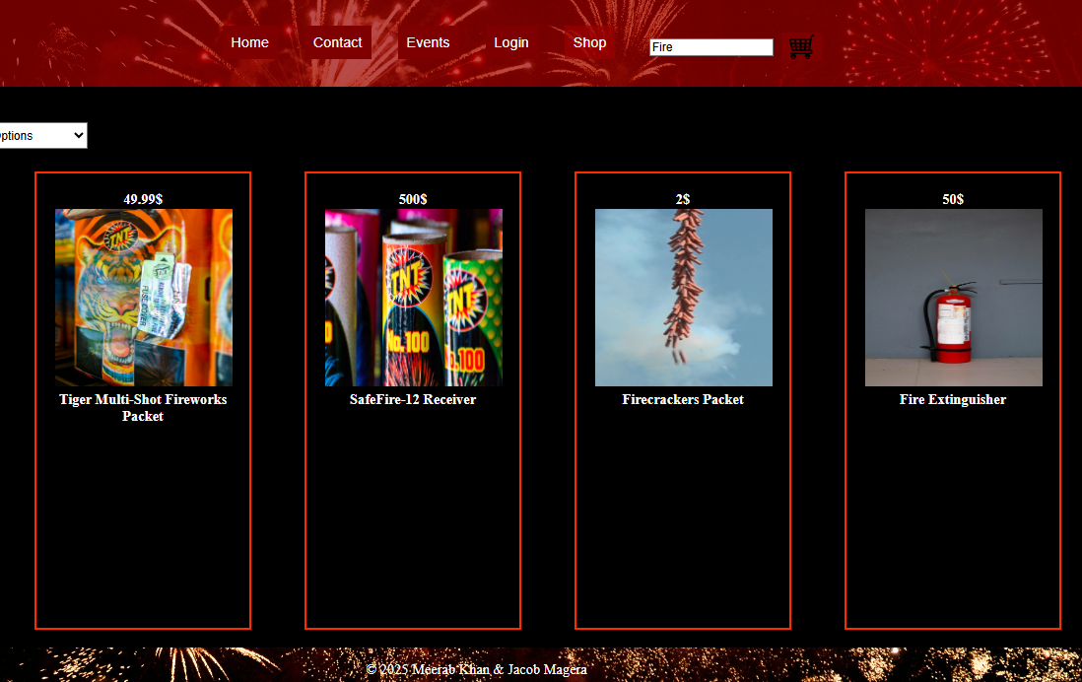

Remote Data Rendering Page

The events page will act as a rendering page for fetching Api of different events. The API we chose to use is for rocket launches for this project because it is closely related to launches that fireworks can do. After the user clicks on the show events button, the API appears in a table format.

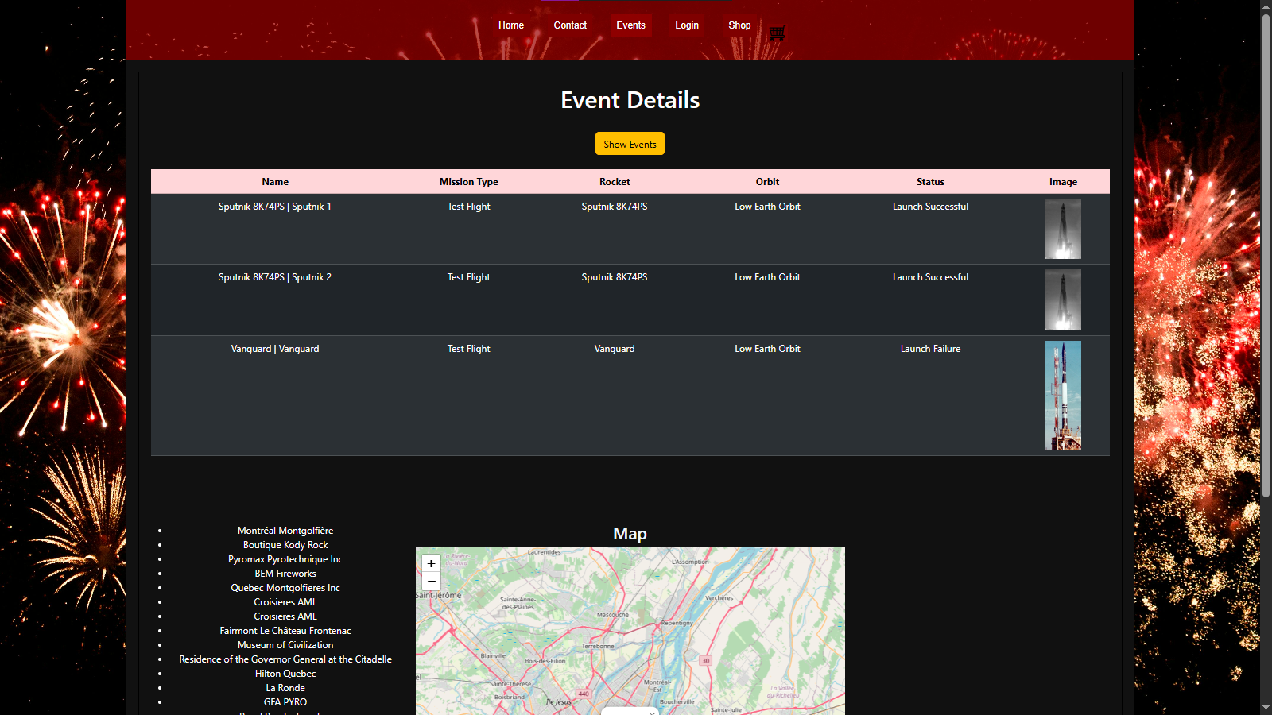

The events page also includes a map and different locations of interest. After the user clicks on the title of the location like Boutique Kody Rock a marker appears with a tooltip above the location in map:

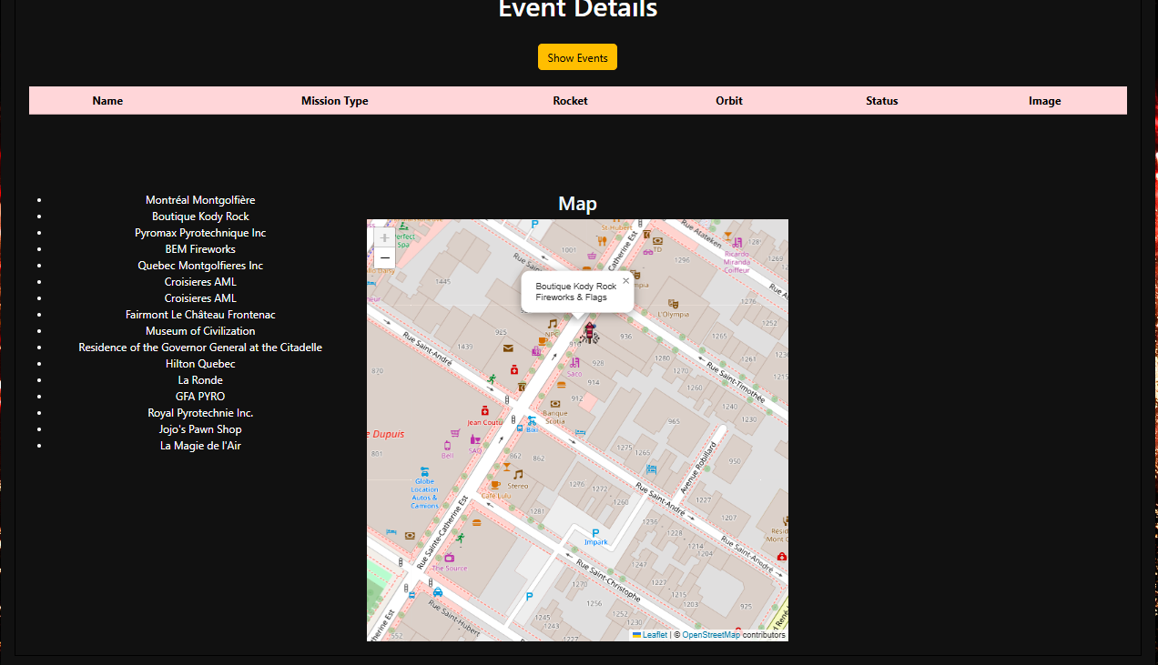

Page responsive:

The website is responsive from small iPads to big screens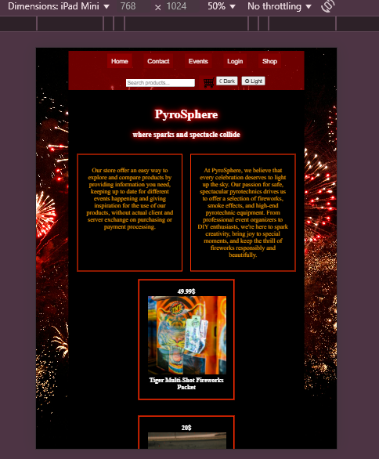

GitHub: <https://github.com/MEERABLK/pyrotechnics-store>